**Solving a murder case with different denoising methods**

In this paper, I am going to discuss various approaches to solve a murder case where the murderer has left his/her tool who has committed a crime in the office. By denoising the image we are going to find out whether this tool is there or not and to realize which one of the methods is the most efficient.

**Gaussian Filter**

It is a method of filtering high-frequency content and letting the low frequency remain the same. It can smooth a signal because sharp values between signal values are removed when high frequencies are removed through a weighted average of local signal values. for 2D images, we need 2-D low pass filters (like 2D gaussian) – with 2D convolution our filter is 2D and it is sliced to locations over the 2D range of the image. gaussian filter weights the importance of image samples near the center of the image filter, highest in the weighted avg- importance of weightings in the weighted average taper off as we move to the edges of the filter window in both directions and of course Center pixel weighs more than the others. Of course, it is called Gaussian Smoothing because sharp transitions between pixels are removed when the high frequencies are removed using local average operation. By doing so the image will be denoised and the image edge sharpness will be degraded.

Sigma should be chosen based on scale and the magnitude of the noise that is going to be smoothed away like for Noise which is independent across pixels such as static type white noise low sigma value is okay. Gaussian is like diffusion because if there were edges we were averaging across them and mixing them up so they turned blurry.

**Isotropic and Anisotropic**

Diffusion is a physical process that minimizes the spatial concentration u(x,t) of a substance gradually over time. Isotropic is when pixels go around in both cases of having and not having a boundary. Anisotropic diffusion only goes to average pixel values only on the right side of the object or edge and we are not averaging across edges so it is sharper and preserve the edges it has been made to overcome the blurry images that Gaussian, median, and mean filters cause so the noise reduction is happening here.

**What is PDE?**

Think of things at a very small scale and in an iterative process: by doing so we have PDEs(partial differential equations). (image processing is the result of iteration of infinitesimal operations: PDEs).

**Convolution**

Convolution is another operation for image filtering which takes each column and flips it both horizontally and vertically before being applied to the image

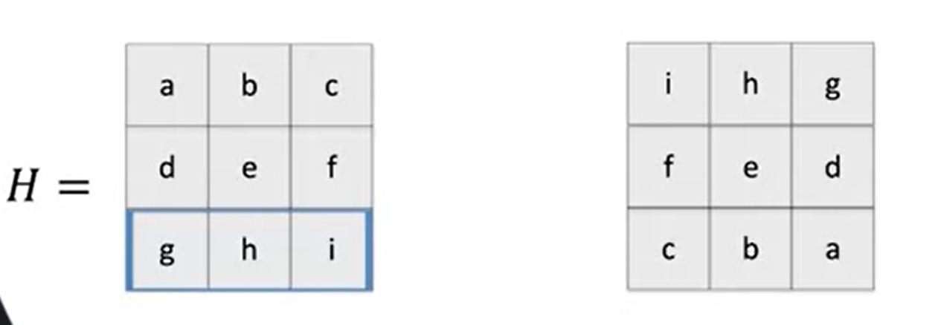

Unlike cross-correlation, convolution is associative. If H and F are filter kernels we would have:

**H * (F*I) = (H*F)*I**

I is image of course.

**Diffusion PDE**

The following figure shows the PDE of general diffusion (from Fick’s law), where the diffusivity g becomes a constant, the diffusion process becomes linear, isotropic, and homogeneous.

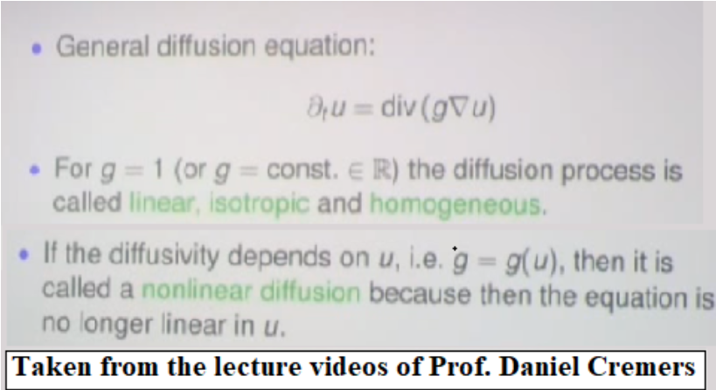

In linear diffusion, the rate of diffusion depends only on gradient (rate of change of pixel intensities at a given point) irrespective of pixel coordinates. Hence, the process is also known as isotropic diffusion. the linearity guarantees that the diffused image can be written as a convolution of the image with the time evolution of δ-functions. To enable diffusion in an image, we’ve to apply a direction invariant filter to it. Usually, a [Gaussian filter](https://en.wikipedia.org/wiki/Gaussian_filter) is a better option. Hence, linear diffusion is also known as Gaussian diffusion.